**Project Design Phase-I**

**Solution Architecture**

|  |  |
| --- | --- |
| Date | 19 September 2022 |
| Team ID | PNT2022TMID48304 |
| Project Name | Project - IoT Based Smart Crop Production System for Agriculture |
| Maximum Marks | 4 Marks |

**Solution Fit Document**

**1. Customer Segment:**

The farmer faces difficulty to maintain crops in larger area.

**2. problems/pains:**

* Cope with climatic change, soil erosion and biodiversity loss.
* When darkness falls across the farm cows, pigs, sheep, chickens entered into the farm and destroys the crop.

**3. Triggers to act:**

Feeding a growing population, providing a livelihood for farmers, protecting the environment.

**4. Emotions:**

The emotional effects of farmers are frustrated, disappointed, unfulfilled, anger, fear.

**5. Available Solutions:**

* Install new or existing internet lines such as wifi and fiber optics in our location.
* Invest more in farm productivity.
* Adoption of new technologies better crop production.

**6. Customer Limitation:**

Farmer can afford the equipment but there is unavailability of electricity 24*7 in the village areas.

**7. Existing System:**

* Traditional agriculture is based on treating soil and plants with products which are not noxious not synthetically produced in laboratory.
* Organic agriculture is a holistic production management system which promotes and enhances agro ecosystem health, biological cycles, soil biological activity.
* Conservation Agriculture (CA) is a farming system that can prevent losses of arable land while regenerating degraded lands. It also improves irrigation production.

**8. Customer behavior:**

* The farmers must to know how to process seeds and prepare fields for planting.
* It can be done by better analysis of soil and plant conditions and provide actuate information about weather conditions.

**9. Problem Root/Cause:**

* Irrigation is crucial for farm sector where large tracts of land still depend on monsoon rains.
* climatic change, pollutants, irrigation problem, soil degradation, waste.

**10. Solution:**

* We can know the real-time status of the crops by capturing data from sensors, using predictive analysis, we can make better decisions related to harvesting.
* It uses modern technology to increase quantity and quality of agriculture products.

**Solution Architecture Diagram:**

|  |
| --- |
| **IMG-20221026-WA0001.jpg**  **IMG-20221026-WA0006.jpg**  IMG-20221026-WA0004.jpg  IMG-20221026-WA0007.jpg    IMG-20221026-WA0003.jpg |

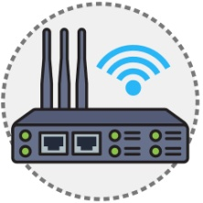

**Edge Gateway Real Time Access**

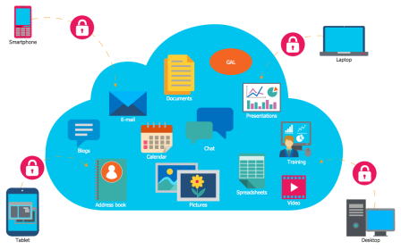

**Could Services**

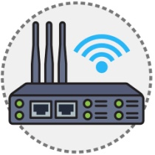 **Request**  **Response**

**Edge Gateway**



**Smart Device User and Farmer**